Documentation on Integrating the concept of Eidolism in Pong

By Adithyan K R

Eidolism
- Eidolism is the belief that the world we see is made up of images, illusions, or reflections rather than solid reality. The word comes from the Greek eidolon, meaning “image” or “phantom.” It suggests that what we experience through our senses is only a picture shaped by our mind, ie, not the true nature of things. In philosophy, Eidolism connects to ideas like idealism, which say that reality exists as perceptions or thoughts instead of physical matter.
- In art, Eidolism represents a love for appearances, beauty, and idealised forms. Artists or writers influenced by it often try to capture the perfect image or emotion rather than the real, imperfect life. It values how things look or feel more than what they truly are.
- Spiritually, Eidolism can refer to the belief in spirits, ghosts, or afterimages — that every being leaves behind an echo or shadow of itself. This connects it to myths and dreams, where the boundaries between the real and the imagined fade away.
- Overall, Eidolism explores the line between appearance and truth, asking whether what we see is real or just a reflection of something deeper, hidden, or imagined.

Eidolism in Pong
I integrated the philosophy of Eidolism in pong. Eidolism means belief in ghosts. Pong is a game about a ball and two paddles, in which the player needs to control the paddles and make sure to not miss the balls. But here the twist lies in the ball as the ball navigates, it behaves like a ghost. The ball vanishes at certain points as well as it spawns multiple balls at the same time, in which only one ball will be the real one. There is also another ability in which the ball warps and spawns at random position once it touches the top or bottom walls (this ability is called ghost ball).

Start screen
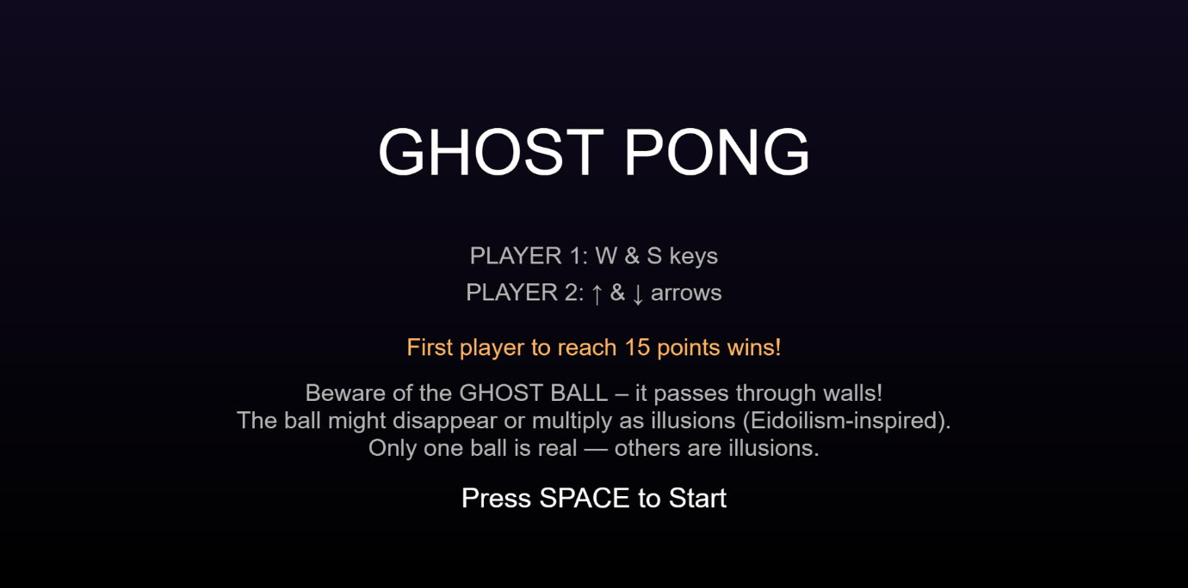

The disappearing ability of the ball


Spawning of multiple balls
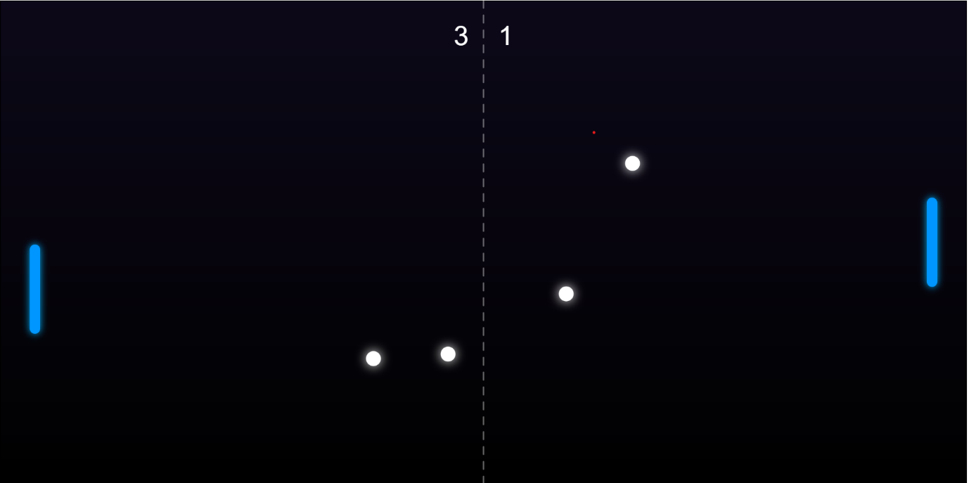

Appearance of the ghost ball.
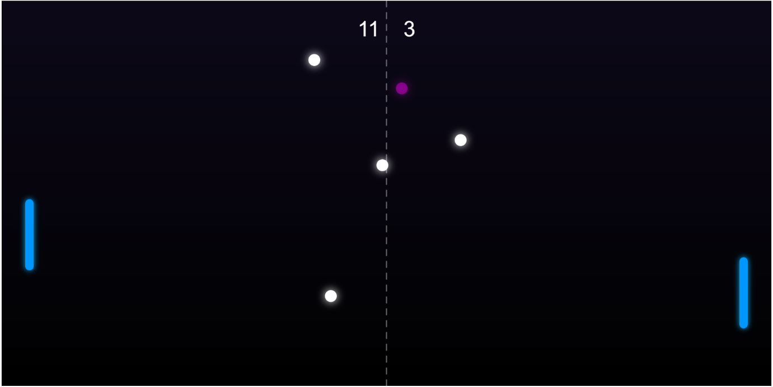

End screen
